Hi Mark,

I hope this finds you well! Paul Hanson suggested I reach out to you for clarification on the metadata for the limnological buoy at Lake Mendota.

Specifically, our group has been looking at the chlorophyll and phycocyanin data from the fluorescence sensors. It seems like there might be some inconsistencies across years in the scale of this data:

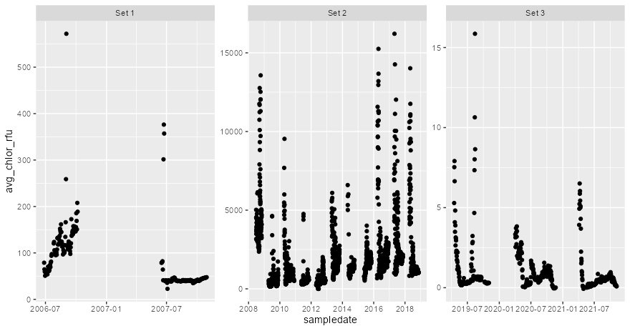

I noticed in the EDI metadata that there should be a list of sensors used since 2006, but I haven't been able to track down that CSV. Would you potentially be able to share that? or do you have other thoughts on how to ensure that this data is comparable across years?

Thanks so much - and apologies if I missed this somewhere in the existing metadata!

Caroline

_____________________________

Hi Caroline,

We switched chlorophyll and phycocyanin sensors in 2019. The old one was made by Turner and the new one is YSI. They both output RFU but at significantly different scales. The sensors CSV is attached (it’s on our website but not on EDI apparently).

I’ve also attached data from 2019 in which we had both sets of sensors deployed. Note that the Turner was located below the buoy where we could not clean/calibrate it throughout the season and subsequently suffers significant bio-fouling. The new YSI is accessible and was cleaned/calibrated (roughly) bi-weekly.

Hope this clears things up a bit.

Mark

_____________________________

This is a huge help Mark, thank you!!!

Do you think there was anything different in 2006-2007 vs. 2008-2019 for the Turner sensor (maybe not cleaned as often?) or was there really that much less pigment in the water then?

Warmly,  
Caroline

_____________________________

That was before my time, but the buoy was new then and the Turner had an adjustable sensitivity range. It may have been changed after 2007 as the crew gained some experience with the lake. And, unfortunately, our manually sampled chlorophyll dataset excludes those years due to other measurement problems (see the abstract at [this link](https://lter.limnology.wisc.edu/dataset/north-temperate-lakes-lter-chlorophyll-madison-lakes-area-1995-current)). Sorry, but those might be lost years.